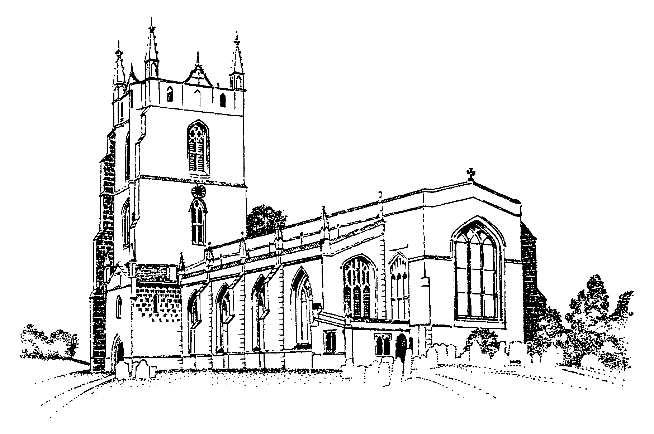
MONKS KIRBY PARISH COUNCIL

E-mail: monkskirbypc@outlook.com
Web: www.monkskirby.org.uk

Minutes of the Parish Council meeting held on Tuesday 9th April 2024.
Meeting started 6.30pm.

Attendees: Cllr. Paul Woods (Chair), Cllr Louise Partridge, Cllr C Clarke (Deputy Chair), Cllr. John Dalby, Cllr Bill Woolliscroft, P Clegg (Clerk).

2456- Apologies and approval.

- Cllr. Barbara Dent - Approved by Councillors.

2457 - Declarations of Interest with regards to items on the agenda.

- None.

2458 - Public Participation Session (15 minutes).

- None

2459 – Feedback from WCC & RBC

- Cllr Warwick sent his apologies
- Cllr Gillias discussed R23/0850 Travellers site at the end of Millers Lane – Action Clerk to forward recent correspondence with RBC to Cllr Gillias and raise issues raised with RBC Planning directly.
- Cllr Gillias discussed R22/1006 Stables on the Hayes – Action Clerk to forward recent correspondence with RBC to Cllr Gillias and raise issues raised with RBC Planning directly.

2460 - Approval of Minutes of the Monthly meeting held on 12th March 2024.

- Approved by Councillors.

2461 - Matters Arising from the Minutes of the meeting held on 12th March 2024.

- Approved by Councillors.

2462 - Finances – On-line Payments for approval

- Approved by Councillors.

Payee | Date | Invoice | Amount
Emily Hobson – Playground maintenance | 01/03/24 | March | £112.00
EON street light maintenance charge | 12/03/24 | 122905 | £74.40
P Clegg/Hobby Craft - Stationery | 15/03/24 | n/a | £29.60

2463- Finance

- Bank reconciliation for agreement - Approved by Councillors.
- Receipt of 1st precept payment £5581.00 - Approved by Councillors.
- Interest from savings accounts £10.92 & £ 120.56 - Approved by Councillors.
- Bank Service charge £18.00 - Approved by Councillors.
- Transfer money from Saving to current to pay for street light £2875.20 - Approved by Councillors.

2464 - Fishponds

- Action Cllr Partridge to continue estimates and time scales for repair to swing and evaluate hours required by playground contractor

2465 - Planning

- R23/1270 Old Butchers Shop – Action Clerk to request status update from RBC

2466 - Solar Farm Grant

- Additional street light in Brockhurst Lane – Order raised work set for 22/4/24

2467 – Tree Pruning

- No action required. We will monitor the situation.

2468 – Litter picking

- Advised by WALC that risk assessment required ahead of any organised event – Action Clerk to complete Risk assessment for next year.
- Rubbish from litter pick event not yet cleared – Action – Clerk to contact RBC.

2469 – Local Elections

- No remaining actions required by team
2470 – Annual Parish Meeting

- Councillors to decide / confirm on a date. Action Clerk to book 19th June.

2471 – Assets Register

- Action Clerk to review depreciation values.

2472 – Recent Traffic survey

- Awaiting final results from latest study – Action Cllr Woods to request summarised data when survey complete.

2473 - Round the revel / whatsapp / website / noticeboard

- Action Cllr Partridge to add the following points
  - Radio 4 broadcast of St Ediths church Bells.
  - Installation date for lamp post.
  - Parish council election update.
  - Thank you for all the litter pickers

2474 - Parish Information (for information exchange only).

- Discussion on pre internal audit – Action Cllr Woods and Clerk to complete.
- Cllr Woolliscroft informed the Councillors that he would no longer attend Magna Park Liaison Meetings and requested that future meetings should be attended.
- Cllr Woolliscroft stated that this would be his last meeting as Councilor. All the Parish Council would like to thank Bill for his 40 years of service with the Parish Council.

Meeting closed 8.00pm

Next Parish Council Meeting – 14th May 18:30

