Monks Kirby Parish
Affordable Housing for Sale Assessment

December 2020

Monks Kirby Parish
Affordable Housing for sale assessment

November 2019

[Company name] | [Company address]
[Document subtitle]
Gary Kirk
Affordable housing for sale
Purpose
This report provides an assessment of the need for affordable housing for sale in the Parish of Monks Kirby within the Rugby Borough of Warwickshire.
Affordable housing is not merely cheaper housing, but planning terminology meaning those forms of housing tenure that fall within the definition of Affordable Housing set out in the current National Planning Policy Framework (NPPF), namely: social rent, affordable rent, affordable private rent and forms of affordable housing designed to offer affordable routes to home ownership.
This will help to inform the emerging Neighbourhood Plan in relation to the opportunities to both identify the need for affordable housing for sale and to see how the Neighbourhood Plan can address the issue.
Context
According to the latest annual Halifax Rural Housing Review (Halifax, 2017), homes in rural areas across Great Britain are 20% more expensive on average than in urban areas. In financial terms, this percentage equates to £44,454.
However, regionally, these figures increase or decrease dramatically depending on the locality. For example, the West Midlands is the region that commands the highest rural premium across Great Britain. Here, the average house price in rural areas is 47%, or £89,272 higher than the region’s urban areas, and in contrast, the East of England has the lowest rural housing premium of 9% or £27,765.
Data from the review shows that first time buyers have more or less found themselves priced out of rural areas. They account for 41% of all mortgaged products in rural areas, compared with 53% in urban areas. Affordability is the main reason for this.
In a local context, figures for the West Midlands show a 38% increase in rural average house prices in the period 2012 - 2017. This equates to a rural housing premium of £55,426, compared to urban locations.
Areas which are predominantly rural typically have higher house prices than urban locations, thus making them less affordable. In 2016, the average lower quartile house price was 8.3 times the average lower quartile earnings in rural areas, in comparison with 7 times in urban areas.
In 2018, the National Housing Federation stated that ‘the housing crisis in rural England is acute, with the most affordable rural homes costing 8.3 times wages in rural areas (National Housing Federation, 2018).

Monks Kirby
The Village Design Statement describes Monks Kirby as being situated two miles south of the watershed that separates the Trent and Severn catchment areas. The high ground to the north is comparatively flat with large open fields now mainly arable, punctuated by occasional stands of timber. The mantle of the plateau is of thick glacial drift, comprising clays, gravels and sands. The village lies in a south facing shallow valley where until recently the heavy soil gave impeded drainage. Recent agricultural policy has removed many of the eighteenth century field boundaries and has installed modern land drainage systems. Originally Monks Kirby and its neighbour Brockhurst were distinct settlements separated by low lying marshland The road that now connects them is in fact built on a causeway. The village is drained by the Smite Brook which rises two or three miles to the north-east and forms the southern boundary of the village. Originally this meandered through boggy water meadows but it has now been straightened and excavated. A small tributary flows southwards down the Monks Kirby valley and separates the twin villages.
According to the 2011 Census, the Monks Kirby Parish had an estimated population of 445 residents living in 181 households dispersed across 1,841 hectares, equating to a population density of 0.2 persons per hectare which is in lower than the borough (2.9), region (4.3) and England (4.1) averages. There were 8 vacant dwellings representing a 4.2% vacancy rate. There were 2 communal establishments situated in the parish boundary.
It is estimated that the number of people living in the parish increased by 2.3% (10 people) between 2001 and 2011. During the same period the number of dwellings (occupied and vacant) increased by 8% (14 dwellings).
At the time of the 2011 Census, around 14% of residents were aged under 16 which was lower than the borough (19%), regional (20%) and national (19%) rates. Around 63% of residents were aged between 16 and 64 which was in line with the borough but below region (64%) and England (65%) rates.
There was an over representation of older people (aged 65+) accounting for 23% of total residents compared with 17% for the borough and region and 16% for Eng1land as a whole. The median age of people living in the local area was 49 which was older than the borough (40), region (39) and England (39) rates.

Table 1: Usual Residents by Age Band, 2011
 | Monks Kirby |  | Rugby | West Midlands | England
 | No | % | % | % | %
Aged 0-4 |  | 14.2 | 19.4 | 19.5 | 6.3
Aged 5-15 | 17 | 3.8 | 6.3 | 6.3 | 12.6
Aged 16-64 | 46 | 10.3 | 13.1 | 13.2 | 64.8
Aged 65+ | 280 | 62.9 | 63.3 | 63.6 | 16.3
All Usual Residents | 102 | 22.9 | 17.3 | 16.9 | 100.0
Median age | 49 |  | 40 | 39 | 39
Source: Census 2011, KS102
A more detailed breakdown of age bands reveals that at the time of the 2011 Census, Monks Kirby had a lower share of people aged been 20 and 39 which may reflect lack of affordable and suitable accommodation for young people entering the housing market. In contrast there was a higher representation of older residents, particularly amongst the 50 to 69 age bands.
Figure 1 Population by 10 year age bands, 2011
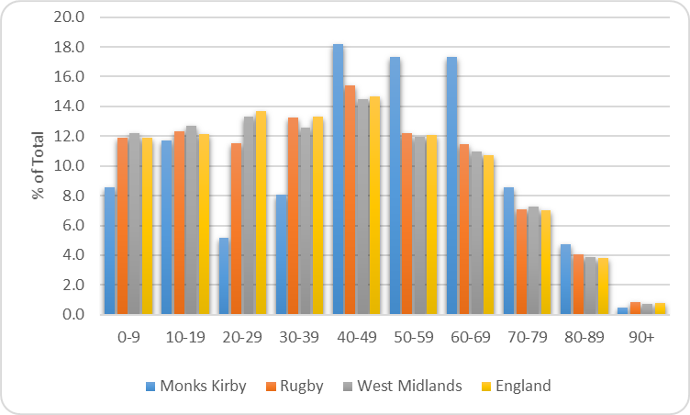
Source: Census 2011, QS103

The Census data suggests evidence of an ageing population with the number of people aged 65 and over increasing by 65% (40 residents) between 2001 and 2011. Over 65s represented 14% of total population in 2001 compared with 23% by 2011.
More recent small area population estimates suggest the number of people living in the parish has continued to grow, increasing by 2% (9 people) between 2011 and 2018. Furthermore, the number of older people increased by 8% and research shows the number of older people will grow significantly in the future and relative growth will be highest in older cohorts. Latest available population projections suggest that Rugby’s 65 plus age group is forecast to grow by around 43% between 2016 and 2036.
Deprivation
The English Indices of Deprivation measure relative levels of deprivation in 32,844 small areas or neighbourhoods, called Lower-layer Super Output Areas (LSOAs) in England. The Monks Kirby Parish is situated within one LSOA (E01031160) which also includes several other small settlements (Stretton under Fosse, Pailton, Brinklow).
The overall Index of Multiple Deprivation Decile (where 1 is most deprived 10% of LSOAs) (IMD) shows that on the whole the local area displays relatively low levels of deprivation ranking in the 6th decile on the overall 2019 Index. The following map illustrates overall Index of Multiple Deprivation deciles within the Rugby borough. The Monks Kirby Parish is denoted by a purple boundary to the north of the borough. However, on closer inspection of the IMD sub domains, the area ranks relatively high (1st decile) on the Barriers to Housing and Services Index. This domain measures the physical and financial accessibility of housing and local services. The indicators fall into two sub-domains: ‘geographical barriers’, which relate to the physical proximity of local services, and ‘wider barriers’ which includes issues relating to access to housing such as affordability and homelessness. The distribution of the most deprived areas on this domain differs greatly from other domains. In fact the picture of deprivation is almost inverted, with the more economically deprived central areas of the borough having better access to affordable housing and key local services. It is the outer areas that suffer greater levels of deprivation in terms of access to services and access to affordable housing.

Figure 2 Index of Multiple Deprivation Deciles, 2019 Rugby
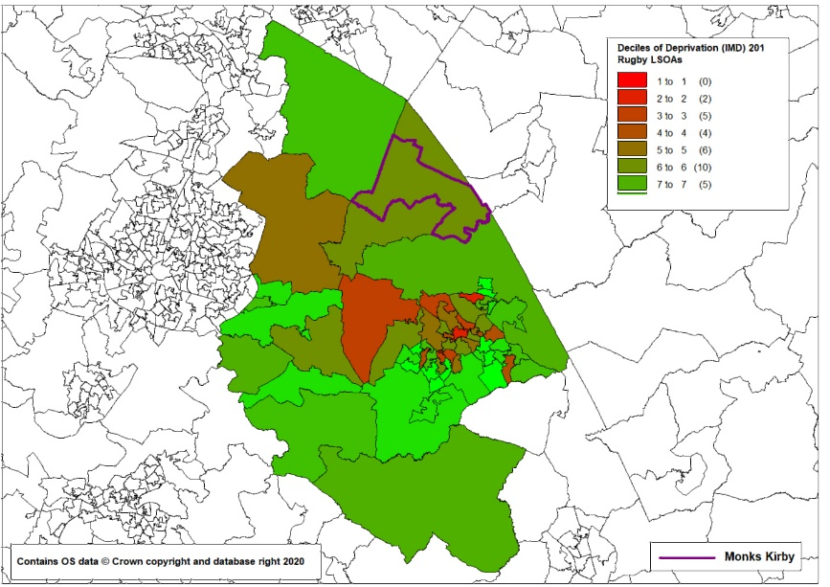
Health
The Census highlights ill health and disability is an issue for some residents. Figure 3 shows that at 4.5% the proportion of residents reporting to be in bad or very bad health but this was in line with the borough but below the region (6.1%) and England (5.5%) rates. Around 16% of residents were providing unpaid care which was higher than the borough (10.4%), regional (11%) and England (10.2%) rates.
Figure 3 Health and Unpaid Care

Source: Census 2011
Economic Activity
The following table illustrates the working status of residents aged 16 to 74 and accounts for 78% of the population. At 66% the Parish economic activity rate was lower than borough (73%), regional (68%) and national (70%) rates. It had a higher than average share of self employed residents. At the time of the 2011 Census the unemployment rate was low.

Table 2: Economic Activity and Inactivity, 2011
 | Monks Kirby |  | Rugby | West  Midlands | England
 | No | % | % | % | %
All Usual Residents Aged 16 to 74 | 348 | 100.0 | 100.0 | 100.0 | 100.0
Economically Active Total | 230 | 66.1 | 73.5 | 68.3 | 69.9
Employee, Part-time | 37 | 10.6 | 13.9 | 14.0 | 38.6
Employee, Full-time | 126 | 36.2 | 44.6 | 37.4 | 13.7
Self Employed | 45 | 12.9 | 8.9 | 8.5 | 9.8
Unemployed | 9 | 2.6 | 3.6 | 5.1 | 4.4
Full-time Student (econ active) | 13 | 3.7 | 2.5 | 3.3 | 3.4
Economically inactive Total | 118 | 33.9 | 26.5 | 31.7 | 30.1
Retired | 78 | 22.4 | 14.7 | 14.4 | 13.7
Student (including Full-Time Students) | 12 | 3.4 | 3.9 | 5.9 | 5.8
Looking After Home or Family | 11 | 3.2 | 3.5 | 4.6 | 4.4
Long-Term Sick or Disabled | 6 | 1.7 | 2.8 | 4.4 | 4.0
Other | 11 | 3.2 | 1.5 | 2.4 | 2.2
Source: Census 2011, QS601E
Household Size
At the time of the 2011 Census, the average household size in the Monks Kirby Parish was 2.5 people compared with 2.3 for the borough and 2.4 for the region and England respectively. The average number of rooms per household stood at 7.0 which was above the borough (5.7), region (5.5) and England (5.4) rates.
The average number of bedrooms per household stood at 3.4 which was higher than the borough (2.9), region (2.8) and England (2.7) rates.
National Planning Policy Context
The National Planning Policy Framework (NPPF - updated in 2019) confirms the Government’s commitment to home ownership, whilst recognising the important role of social, affordable, and private rent tenures for those not currently seeking home ownership.
The 2019 update of the NPPF broadens the definition of affordable housing from merely social and intermediate housing to include a range of low-cost housing opportunities for those wishing to own a home, including starter homes.
Annex 2 defines affordable housing in the following terms:
Affordable housing: housing for sale or rent, for those whose needs are not met by the market (including housing that provides a subsidised route to home ownership and/or is for essential local workers); and which complies with one or more of the following definitions:
- Affordable housing for rent: meets all of the following conditions: (a) the rent is set in accordance with the Government’s rent policy for Social Rent or Affordable Rent, or is at least 20% below local market rents (including service charges where applicable); (b) the landlord is a registered provider, except where it is included as part of a Build to Rent scheme (in which case the landlord need not be a registered provider); and (c) it includes provisions to remain at an affordable price for future eligible households, or for the subsidy to be recycled for alternative affordable housing provision. For Build to Rent schemes affordable housing for rent is expected to be the normal form of affordable housing provision (and, in this context, is known as Affordable Private Rent).
- Starter homes: is as specified in Sections 2 and 3 of the Housing and Planning Act 2016 and any secondary legislation made under these sections. The definition of a starter home should reflect the meaning set out in statute and any such secondary legislation at the time of plan-preparation or decision-making. Where secondary legislation has the effect of limiting a household’s eligibility to purchase a starter home to those with a particular maximum level of household income, those restrictions should be used.
- Discounted market sales housing is that sold at a discount of at least 20% below local market value. Eligibility is determined with regard to local incomes and local house prices. Provisions should be in place to ensure housing remains at a discount for future eligible households.
- Other affordable routes to home ownership is housing provided for sale that provides a route to ownership for those who could not achieve home ownership through the market. It includes shared ownership, relevant equity loans, other low-cost homes for sale (at a price equivalent to at least 20% below local market value) and rent to buy (which includes a period of intermediate rent). Where public grant funding is provided, there should be provisions for the homes to remain at an affordable price for future eligible households, or for any receipts to be recycled for alternative affordable housing provision or refunded to Government or the relevant authority specified in the funding agreement.
Paragraph 62 of the NPPF says ‘where a need for affordable housing is identified, planning policies should specify the type of affordable housing required, and expect it to be met on-site’ unless off-site provision or a financial contribution can be robustly justified; or an alternative approach contributes to the objective of creating mixed and balanced communities.
In paragraph 64 of the NPPF, the Government introduces a recommendation that “where major housing development is proposed, planning policies and decisions should expect at least 10% of the homes to be available for affordable home ownership”. In line with Planning Practice Guidance, the assumption is that a ‘major housing development’ can be defined as a site of 10 dwellings or more, and that affordable home ownership includes starter homes, shared ownership homes, and homes available for discount market sale.
Paragraph 77 supports opportunities to bring forward rural exception sites that will provide affordable housing to meet identified local needs.
The NPPF defines self-build housing as ‘housing built by an individual, a group of individuals, or persons working with or for them, to be occupied by that individual. Such housing can be either market or affordable housing. A legal definition, for the purpose of applying the Self-build and Custom Housebuilding Act 2015 (as amended), is contained in section 1(A1) and (A2) of that Act’.
The NPPF (paragraph 61) requires local planning authorities to plan for a mix of housing needs, including for older people and people with disabilities.
Neighbourhood Plan policies are required to have regard for national planning policies.
Local Planning Policy context
The Rugby Local Plan 2011 – 2031 was adopted in September2016. It references Affordable Housing throughout the document.
Monks Kirby is a Rural Village where the Local Plan says generally ‘Development will be permitted within existing boundaries only, including the conversion of existing buildings where national policy permits’ (p11). The Local Plan goes on to state ‘…smaller rural villages are protected from excessive development that would be harmful to their respective character and function, but in order to meet the overall housing requirement for the Borough further development is required’ (p24).
So it is clear from the Local Plan that some form of development is necessary in Rural Villages.
This is reinforced in relation to affordable housing where the Local Plan says in paragraph 3.13 ‘Some schemes, such as those submitted under the rural exception affordable housing policies or as community led development schemes, may come forward on sites outside the defined settlement boundaries of Main Rural Settlements and Rural Villages’. Paragraph 5.4 goes further by saying ‘The Local Plan will not generally allow for new-build housing to be provided outside the limits of any defined settlement within the Borough. However, reflecting the advice in national policies and the extent of the affordable housing need in the rural area, the policies of this Local Plan outline a criteria-based approach under which applications for Rural Exception Sites will be considered. This will therefore continue the opportunity to allow for some affordable housing in the rural area.
Policy H2 on Affordable Housing states:
‘Affordable housing should be provided on all sites of at least 0.36 hectares in size or capable of accommodating 11 (net) dwelling units or more (including conversions and subdivisions).
On previously developed sites a target affordable housing provision of 20% will be sought. On green field sites a target affordable housing provision of 30% will be sought.
The mix of units within this percentage of provision must be in compliance with guidance contained within the Housing Needs SPD.
The target levels will be expected to be provided unless the local planning authority is satisfied by robust financial viability evidence that development would not be financially viable at the relevant target level. Such evidence will be required to be submitted with the planning application to justify any reduced levels of affordable housing provision proposed for assessment using an open-book approach and may be subject to independent assessment (e.g. by the District Valuer Services or equivalent).
Development should provide for the appropriate integration of affordable housing and market housing, in order to achieve an inclusive and mixed community.
Further details of requirements are contained in the Housing Needs SPD which should be read in conjunction with this policy’.
Perhaps of more relevance to Monks Kirby is Policy H4 on Rural Exception Sites. This policy states:
‘The development of affordable housing that meets the needs of local people will be permitted as a Rural Exception Site adjacent to defined rural settlement boundaries, where development is normally resisted, if all of the following criteria are met:
a) It is clearly demonstrated that there is a local need for affordable housing which outweighs other policy considerations;
b) It is demonstrated no suitable alternative sites exist within the defined settlement boundary;
c) The development consists exclusively of affordable housing;
d) Developments do not have an adverse impact on the character and/or appearance of settlements, their setting or the surrounding countryside; and
e) Safeguards are in place to ensure homes remain affordable in perpetuity.

In all cases arrangements for the management and occupation of dwellings must be made to ensure that all dwellings provided will be, and will remain available for occupancy by eligible local people at an affordable cost and at a range of tenures, both initially and in perpetuity.
In some circumstances a small proportion of open market housing may be allowed where it can be shown that the scheme will deliver significant affordable housing and viability is a key constraint’.
Paragraph 5.1 confirms that ‘The principle aim of Policy H4 is to provide affordable housing for local people which cannot be delivered within the adjacent settlement boundary’.
The level of need identified in the Local Plan is described as follows ‘The Coventry and Warwickshire Joint Strategic Housing Market Assessment update September 2015, identifies an affordable housing need of 171 dwellings per annum for Rugby Borough which equates to 36% of the total OAN. However, this Local Plan seeks to deliver a housing target which incorporates some of the housing need emanating from Coventry City, which the City authority cannot meet within its own boundaries. For Coventry City the affordable housing need represented 28% of its total annual OAN. The target contained within the Policy H2 will clearly ensure that affordable housing need is met for all existing and future residents of the Borough’ (p39).
The Local Plan identifies a need for smaller dwellings generally – 50%-60% to be 2/3 bed dwellings. The precise tenure mix is to be determined by evidence of local need, but in 2016 was identified as 84% social or affordable rent and 16% intermediate.
Approach
The approach undertaken was to consider a range of local factors in the context of the NPPF and the Rugby Local Plan. These included assessments of local demographic data relating to existing property types and tenures (taken from the 2011 Census), house prices in Monks Kirby Parish (Land Registry figures); comments made through community consultation including analysis of a Housing Need Survey undertaken in June 2013 and consideration of housing need in Monks Kirby Parish in conjunction with strategic affordable housing officers from Rugby Borough Council.
The neighbourhood planning group would like to understand the needs of the community for housing of varying tenures, as well as the relative affordability of those tenures that should be provided to meet local need now and into the future.
This evidence will allow Monks Kirby Parish to establish the right conditions for new development to come forward that is affordable, both in the broader sense of market housing attainable for first-time buyers, and as Affordable Housing for those who may be currently priced out of the market.
The neighbourhood planning group is seeking to determine what size and type of housing would be best suited to the local community. The aim of this is to provide the Parish Council with robust evidence on the types and sizes of dwellings needed by the local community. This will ensure future development truly reflects what residents need.
Research findings
Existing property types and tenures – Census 2011 data
What Affordable Housing and other market tenures should be planned for in the housing mix over the Neighbourhood Plan period? Tenure refers to the legal arrangements in place that enable a household to live in their home; it determines householder rights and influences the level of payments to be made in return for these rights. Broadly speaking, tenure falls into two categories, Affordable Housing and Market Housing, depending on whether the household benefits from a subsidy of some sort to enable them to live in their home.
This section examines the tenure of dwellings in the current stock and recent supply. Looking at affordability, an assessment is made on whether continuation of these trends would meet future needs. We investigate whether there are misalignments between the supply of different tenures of housing and local need. Such misalignments can justify policies that guide new developments to prioritise certain tenures, to bring supply and demand into better alignment.
Home ownership levels in the parish was high with around 70% of households owning their homes outright or with a mortgage or loan. This was in line with the borough but higher than regional (65%) and national (63%) rates. Around 17% of households live in private rented accommodation which was in line with the national average but higher than the borough and region (14%) rates. Just 8% of households live in social rented accommodation which was lower than the borough (14%), regional (19%) and national (18%) rates.

Table 3: Tenure, 2012
 | Monks Kirby |  | Rugby | West  Midlands | England
 | No | % | % | % | %
All occupied Households | 181 | 100.0 | 100.0 | 100.0 | 100.0
Owned; Owned Outright | 78 | 43.1 | 32.9 | 32.3 | 30.6
Owned; Owned with a Mortgage or Loan | 48 | 26.5 | 36.6 | 32.6 | 32.8
Shared Ownership (Part Owned/Part Rented) | 1 | 0.6 | 1.0 | 0.7 | 0.8
Social Rented; Rented from Council (Local Authority) | 14 | 7.7 | 9.2 | 10.9 | 9.4
Social Rented; Other | 1 | 0.6 | 5.1 | 8.1 | 8.3
Private Rented; Private Landlord or Letting Agency | 30 | 16.6 | 12.6 | 12.8 | 15.4
Private Rented; Other | 1 | 0.6 | 1.5 | 1.2 | 1.4
Living Rent Free | 8 | 4.4 | 1.2 | 1.5 | 1.3
Source: Census 2011, KS402EW
Accommodation Type
Data from the 2011 Census shows the majority (59%) of residential dwellings were detached which was somewhat higher than the borough (28%), regional (24%) and national (22%) shares. Semi-detached housing accounted for 31% of the housing stock against 33% for the borough, 37% for the region and 31% nationally. Terraced housing, flats and apartments provide just 10% of accommodation spaces which was lower than the borough (38%), region (39%) and national (47%) shares.
Table 4: Accommodation Type, 2011
 | Monks Kirby |  | Rugby | West  Midlands | England
 | No | % | % | % | %
All household spaces | 189 | 100.0 | 100.0 | 100.0 | 100.0
Detached | 112 | 59.3 | 28.3 | 23.7 | 22.3
Semi-Detached | 58 | 30.7 | 33.5 | 36.8 | 30.7
Terraced | 13 | 6.9 | 24.9 | 22.9 | 24.5
Flat, Maisonette or Apartment | 5 | 2.6 | 13.1 | 16.2 | 22.1
Caravan/Other Mobile Structure | 1 | 0.5 | 0.4 | 0.4 | 0.4
Source: Census 2011, KS405EW
Number of Bedrooms and Occupancy Rates
More than two fifths (44%) of households live in houses with four or more bedrooms which is higher than the borough (23%), regional (18%) and national (19%) averages. There is an under representation of housing for single people with just 3% of dwellings having one bedroom against 8% for the borough, 10% for the region and 12% for England as a whole.
Table 5 Households by number of bedrooms, 2011
Bedrooms | Monks Kirby |  | Rugby | West Midlands | England
All occupied Household Spaces | 181 | 100.0 | 100.0 | 100.0 | 100.0
No Bedrooms | - | 0.0 | 0.1 | 0.2 | 0.2
1 Bedroom | 6 | 3.3 | 8.2 | 9.6 | 11.8
2 Bedrooms | 40 | 22.1 | 25.0 | 25.3 | 27.9
3 Bedrooms | 55 | 30.4 | 44.0 | 47.0 | 41.2
4 Bedrooms | 52 | 28.7 | 17.4 | 13.9 | 14.4
5 or More Bedrooms | 28 | 15.5 | 5.3 | 4.0 | 4.6
Source: Census 2011, LC4405EW
There is evidence of under occupancy in the local area (having more bedrooms than the notional number recommended by the bedroom standard). Analysis of the 2011 Census shows that around 55% of all occupied households in Monks Kirby had two or more spare bedrooms and around 33% have one spare bedroom. Under occupancy is higher than borough, regional and national averages.
Figure 4: Bedroom Occupancy Rates, All Households, 2011
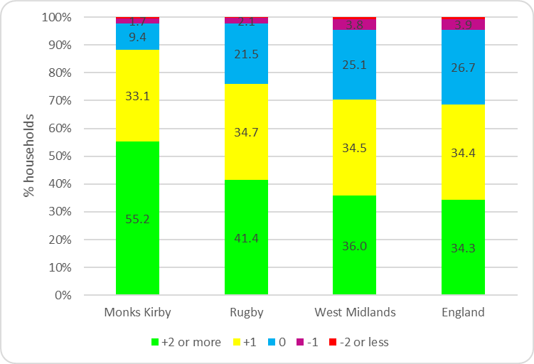
Source: Census 2011, QS412EW
Under occupancy in the local area is particularly evident in larger properties with around 46% of households with 4 or more bedrooms occupied by just one or two people. This is higher than borough (43%), regional and England (41%) rates.
Table 6 Households with 4 or more bedrooms by household size, 2011
 | Monks Kirby |  | Rugby | West Midlands | England
HHs with 4 or more bedrooms | 80 | 100.0 | 100.0 | 100.0 | 100.0
1 person in household | 7 | 8.8 | 9.8 | 10.6 | 10.6
2 people in household | 30 | 37.5 | 33.6 | 30.6 | 30.3
3 people in household | 16 | 20.0 | 19.7 | 18.3 | 18.3
4 or more people in household | 27 | 33.8 | 37.0 | 40.5 | 40.8
Source: Census 2011, LC4405EW
Census data also suggests that older person households are more likely to under-occupy their dwellings. Data from the 2011 Census allows us to investigate this using the bedroom standard. In total, around 68% of pensioner households had an occupancy rating of +2 or more (meaning there are at least two more bedrooms that are technically required by the household) and was higher than the 52% non-pensioner household rate.
Figure 5: Bedroom Occupancy rating of Older Person Households,
Monks Kirby Parish, 2011
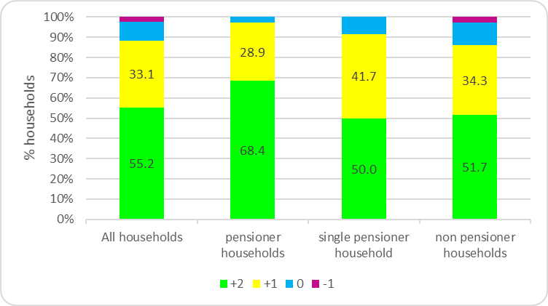
Source: Census 2011, LC4105EW
Overcrowding is not a significant issue in the local area, however, research shows that households with dependent children are more likely to be overcrowded. The Census implies there is some evidence of a small number of families with dependent children living in overcrowded households in Monks Kirby.
Figure 6: Bedroom Occupancy rating of Family Households
Monks Kirby, 2011
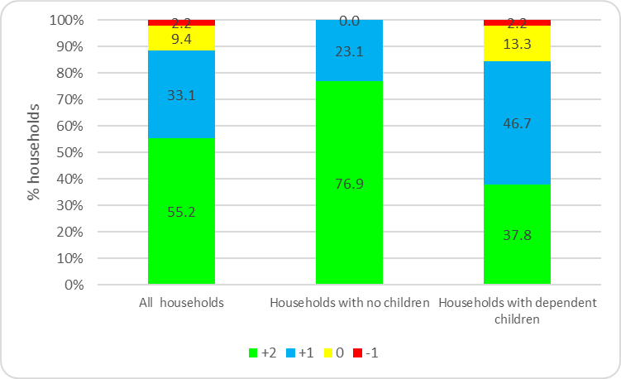
Source: Census 2011, LC4105EW
Housing Market
Residential Sales
Land Registry price paid data shows around 113 residential property sales were recorded in the Monks Kirby Parish between 1995 and 2019. At 62% detached housing accounted for the majority of sales, 23% were semi-detached and 15% terraced properties. It should be noted that some sales are not captured by the Land Registry, for example properties that were not full market value, right to buy and compulsory purchase orders will be excluded.
Figure 7
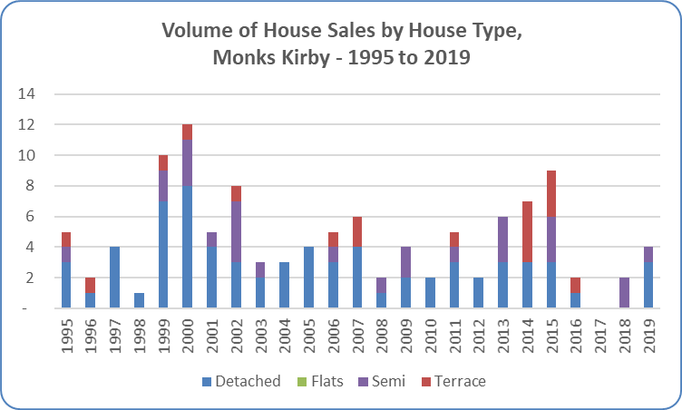
Data produced by Land Registry © Crown copyright 2020 (data available at 30.8.20)
There is evidence of new build housing in the local area with 16 new build residential sales recorded between 1995 and 2019, representing 14% of total sales recorded by the Land Registry in the area. All new builds recorded on the Land Registry price paid data series during this time were detached. Figure 8 below shows the volume of sales together with the overall annual average house price.
Figure 8:
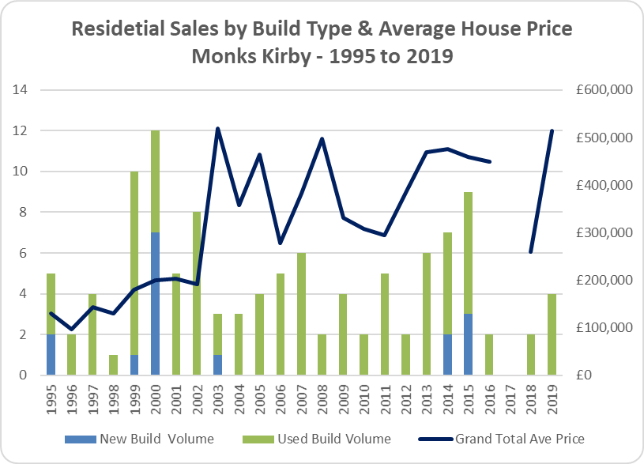
Data produced by Land Registry © Crown copyright 2020 (data available at 18.8.20)
During this period, the majority (63%) of new build residential sales were detached, 31% were terraced and 6% semi-detached properties (Figure 11). It should be noted that not all new builds will be captured in the Land Registry price paid data, eg some conversions and social housing units will be excluded. Newly built dwellings are estimated to be significantly less affordable than existing dwellings.
Figure 9:
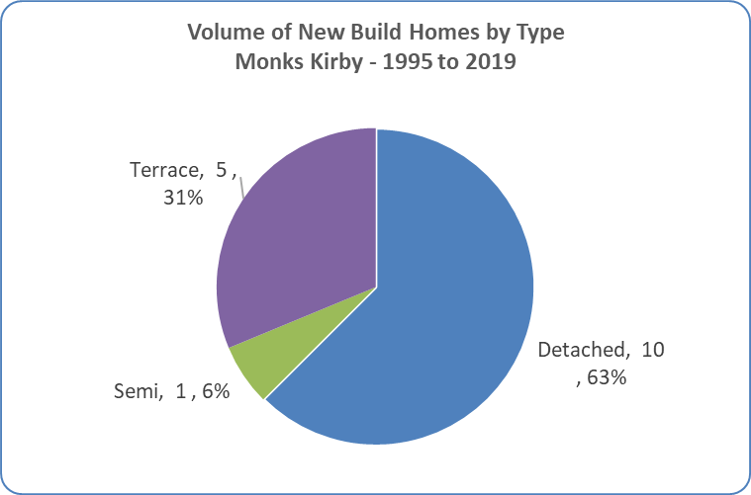
Data produced by Land Registry © Crown copyright 2018 (data available at 18.8.20)

Affordability
The latest housing affordability data for England Wales shows that on average, full-time workers could expect to pay an estimated 7.8 times their annual workplace-based earnings on purchasing a home in 2019. This is a significant improvement from the previous year when the ratio was 8.0.
The housing affordability gap continues to widen between the most and least affordable areas. In Rugby the gap has worsened with average house prices estimated at being 7.7 times workplace-based average annual earnings in 2019 compared with 3.1 times in 1999.
Workplace-based earnings are not available at parish level but as the average 2018 house price in Monks Kirby is above the district, regional and national rates it is presumed the affordability gap also continues to widen. The following chart indicates the linear house price trajectory in Monks Kirby when compared with the district and England and Wales averages. It should be noted, however, that comparisons against larger geographies should be treated with caution.
Latest available figures suggest the 2019 average house price in the Monks Kirby Parish stood at around £513,750 which is higher than the borough average (£273,900) and national (£301,000) average figures (Land Registry Standard Reports, Aug 2020).
Workplace-based earnings are not available at parish level but as the average 2018 house price in Monks Kirby continues to be above district, regional and national rates it is presumed the affordability gap also continues to widen. The following chart indicates the linear house price trajectory in Monks Kirby when compared with the district and England and Wales averages. It should be noted, however, that comparisons against larger geographies should be treated with caution.
Figure 10
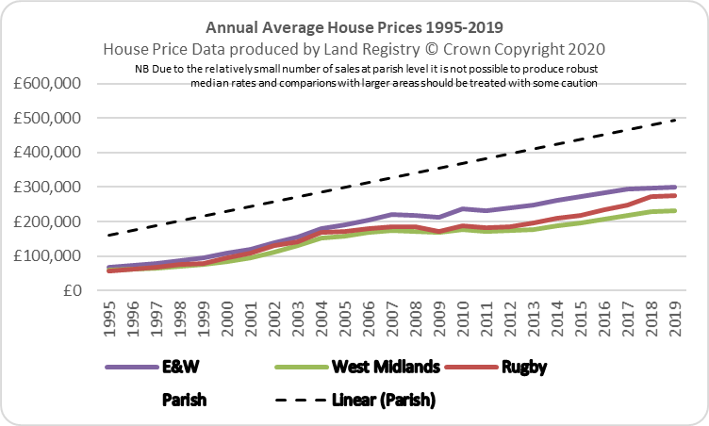
COMMUNITY QUESTIONNAIRE & OTHER OPEN EVENTS
The Community Questionnaire was completed in ………
Parish Council efforts to secure Affordable Housing in the Parish
The Parish Council has been seeking to secure Affordable Housing in Monks Kirby since 1990, when enquiries were received from parishioners. This led to the first Housing Needs Survey being carried out in the Parish in July 1991, establishing a need for six affordable dwellings either for rent or home ownership. A further survey was carried out in 1995 which confirmed the need.
Agreement was reached with the Estate for the development of a small Exception Site and a planning application submitted for a scheme of four dwellings, which was refused by Rugby BC on the basis that it was not allowed under national planning policies.
A further housing needs survey in 2006 drew the same conclusions about need and over the next few years changes in both national and local policies supported Exception Site policies for Affordable Housing.
The Estate confirmed their willingness to support the provision of Affordable Housing and Rugby BC agreed that a scheme was possible in planning policy terms.
Housing Needs Survey 2013
The Monks Kirby Housing Needs Survey questionnaires were delivered to every household in the Parish during week commencing 18th March 2013. The return date for the survey was 15th April and returns were made via a postage paid envelope. Survey forms were distributed to all households as well as to those who said that they had moved away from Monks Kirby or had a strong connection to the Parish and wished to complete a form.
A total of 161 survey forms were distributed and 74 were received in return, giving a return rate of 46% against the number distributed.
The survey was conducted in order to obtain clear evidence of any local housing need for a range of housing tenures for Monks Kirby residents.
The detailed responses to the survey revealed the following:
56% of completed questionnaires came from villagers who do not expect to move home again. 35% of people anticipate their next property being a privately owned home and 4% believe they will move into privately rented accommodation. 4% of respondents expect to move into affordable rented housing.
56% of responses came from households that do not expect to move again. 17% of respondents expect their next home move to be in the next 5 years.
16% anticipate moving in 10-15 years time, whilst 11% of respondents believe they will move in 5-10 years (i.e. up to 2023).
58% of respondents are in favour of an affordable housing scheme for local people, while 23% said that they are not in favour.
12% of respondents did not know whether they would be in favour or not, and 7% did not give a response.
The survey has identified a need for properties to meet the housing needs (i.e. those with a need within 5 years) of those with a local connection. (It should be noted that many more households will be on housing registers and estate agent lists wanting a property, affordable or open market, in Monks Kirby but this survey ascertained those in need who have a local connection to the Parish).
Of the 8 respondents who indicated a housing need:
- 4 were assessed as being in need of affordable housing to purchase
2 x 2 Bed house – affordable/social rented
1 x 3 Bed house – affordable/social rented
1 x 3 Bed house – shared ownership
- 3 was assessed as being in need of open market housing (for local people) to purchase
1 | x | 2 | Bed bungalow – open market with local occupancy restriction
1 | x | 2 | Bed house – open market with local occupancy restriction
1 | x | 3 | Bed house – open market with local occupancy restriction
The remaining respondent was assessed as being adequately housed at present but their housing needs/wants will be recorded by the local authority to inform any future open market developments for larger homes.
Activity since 2013
Rugby BC confirmed its support for development of an Exception Site on Trustee land, but unfortunately, in 2014 the Estate formally put on hold the offer of land.
The matter was revisited in 2017 with support expressed by a range of organisations including local Councillors and Rugby Borough Council.
When contacted, the Estate said that agents were due to look into their land holdings around the village and thus could not consider our request before this had been concluded.
Discussions with Rugby Borough Council strategic housing team
It is reasonable and appropriate for neighbourhood planners to refer to existing needs assessments prepared by the Local Planning Authority as a starting point.
Rugby’s …….
Discussion/analysis of the main issues
At the time of the 2011 Census, the Monks Kirby Parish was home to around 445 residents living in 181 households. Analysis of the Census suggests that between 2001 and 2011 population in the local area grew by around 2% (10 people). During this period, it is estimated the number of dwellings increased by 8% (14).
There is evidence of an ageing population with the number of over 65 year olds rising by 65%, up from 14% of total population in 2001 to 23% in 2011. In line with national trends the local population is likely to get older as average life expectancy continues to rise.
Home ownership levels are high with around 70% of households owning their homes outright or with a mortgage or loan and at 8% the share of households living in social rented accommodation is very low when compared with regional and national rates.
There is evidence of under occupancy suggesting a need for smaller homes of one to two bedrooms which would be suitable for residents needing to downsize, small families and those entering the housing market. Providing suitable accommodation for elderly residents will enable them to remain in the local community and release under-occupied larger properties onto the market which would be suitable for growing families.
There is a predominance of large detached and an under representation of housing for single people with just 3% of dwellings having one bedroom.
Land Registry data indicates some new build housing market activity over recent years. The cost of housing in the local area is high with house prices above the regional and national averages. Accessing affordable housing will be an issue for many first time buyers and people on lower incomes.
Deprivation is not a significant issue in the local area but IMD domain data suggests that some residents may find it difficult to access owner-occupation or access the private rental market.
Consultation with the community has indicated some support for Affordable Housing in the Parish. Specific levels of housing need within Monks Kirby Parish were identified through a housing needs survey undertaken in 2013 which concluded that 3 new affordable rent homes, and 1 affordable home ownership home are required in order to enable local people to be suitably housed within their community.
It was recognised that local needs affordable homes could be developed on a ‘rural exception site’, if available, and subject to local support some open market sale homes could be used to cross-subsidise the affordable homes if required for viability reasons.
The provision of affordable housing in settlements such as Monks Kirby Parish is promoted through both the NPPF and the Rugby Local Plan.
Conclusion
The high house prices in Monks Kirby Parish, coupled with low levels of affordable housing (including just a single affordable home ownership property in the Parish in 2011 - considerably below Borough, region and national levels) alongside current evidence of need demonstrate the importance of providing affordable housing amongst a range of affordable housing and market products. Only 8.9% of swellings fall under the affordable housing definition in Monks Kirby compared to 15.3 across Rugby as a whole).
The high property prices locally mean that subsidised home ownership or rental products offering a discount of around 20% on current values would probably still be unaffordable to most people.
Consideration should be given to developing shared ownership products which allow people to buy a share of the dwelling from around 25% of its value, with the ability to staircase up as circumstances change.
The availability of affordable housing for sale would enable older people as well as young families to access housing locally, potentially serving both to free up larger properties for families at one end, thus helping to sustain older people in the community for longer and reducing the levels of under-occupation in the Parish, whilst also helping sustain local facilities and services by enabling people in low paid employment to live locally and to service local employment such as the School and public houses.
Next Steps
This Neighbourhood Plan affordable housing needs assessment aims to provide Monks Kirby Parish Council with evidence on a range of housing trends and issues from a number of relevant sources. We recommend that the neighbourhood plan group should, as a next step, discuss the contents and conclusions with Rugby Borough Council with a view to agreeing draft housing policies to be contained within the Neighbourhood Plan, bearing the following in mind:
- All Neighbourhood Planning Basic Conditions, but in particular the following: Condition A, namely that the Neighbourhood Plan has regard to national policies and advice contained in guidance issued by the Secretary of State; Condition D, that the making of the Neighbourhood Plan contributes to the achievement of sustainable development; and Condition E, which is the need for the Neighbourhood Plan to be in general conformity with the strategic policies of the adopted development plan;
- The views of Rugby Borough Council – in particular to confirming the tenure balance of affordable housing that should be planned for.
- The views of local residents;
- The numerous supply-side considerations, including local environmental constraints, the location and characteristics of suitable land, and any assessment work carried out through the Call for Sites that is taking place in Monks Kirby Parish; and
- The recommendations and findings of this study.
This assessment has been provided by YourLocale on the basis of housing data, national guidance, local consultation and other relevant and available information current at the time of writing.
Bearing this in mind, it is recommended that the Neighbourhood Plan Group should monitor carefully strategies and documents with an impact on housing policy produced by the Government, Rugby or any other relevant party and review the Neighbourhood Plan accordingly to ensure that general conformity is maintained.
At the same time, monitoring on-going demographic or other trends over the Neighbourhood Plan period will help ensure the continued relevance and credibility of its policies.
Gary Kirk
YourLocale

Population Estimates – Small Area Based, ONS (NOMIS)
Subnational Population Projections for Local Authorities in England: 2016 based
Housing Affordability in England & Wales 2019, ONS

